Question # 1: [10 + 10 = 20 points]: A graph G with 13 edges is shown in Figure. The edges of G have weights given by the following Table
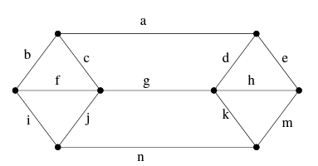
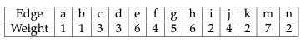
- Use Prim’s algorithm to find a minimum spanning tree S in G. Write the edges of S in the order in which they are added to S by Prim’s algorithm. (If there is more than one possible solution then write only one of them.)
Solution: One possible solution: a, b, i, n, k, c, e
- Use Kruskal’s algorithm to find a minimum spanning tree T in G. Write the edges of T in the order in which they are added to T by Kruskal’s algorithm. (If there is more than one possible solution then write only one of them.)
Solution: One possible solution: a, b, i, k, n, c, e

Question # 2: [4*5 = 20 points]: Write the name and Mathematical Expressions for the following activation functions.
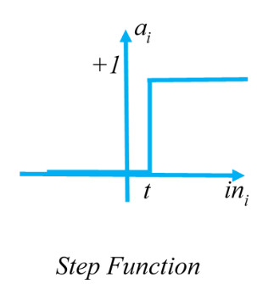 | 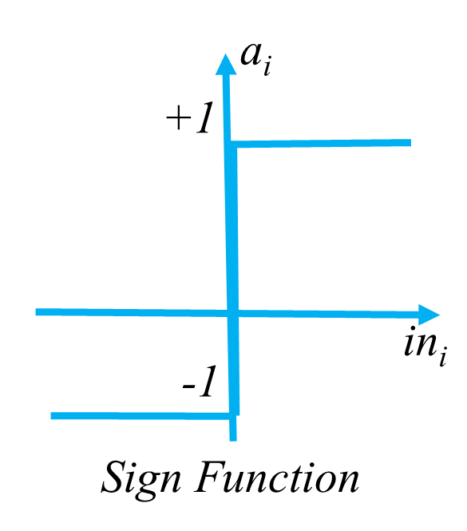 | 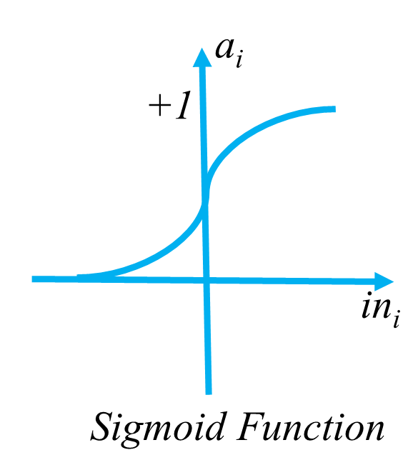 | 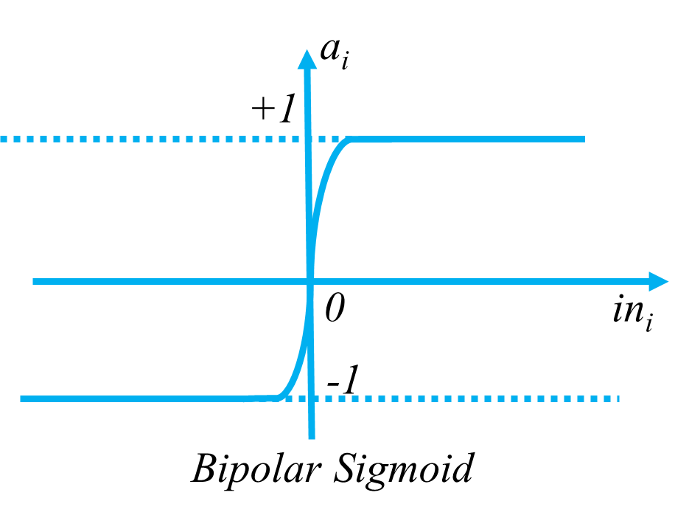 | 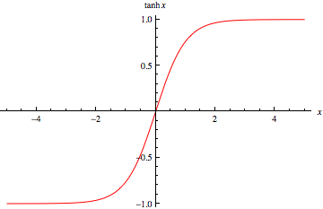
$$f\left(x\right)=\left\{\begin{aligned}0 if x<t \\ 1 if x≥t\end{aligned}\right.$$  Binary Function | $$f\left(x\right)=\left\{\begin{aligned}-1 if x<0 \\ 1 if x≥0\end{aligned}\right.$$  Bipolar Step Function | $$f\left(x\right)= \frac{1}{1+exp⁡(-σx)}$$  Bipolar Function | $$g\left(x\right)= \frac{1-exp⁡(-σx)}{1+exp⁡(-σx)}$$  Bipolar Sigmoid | $$h\left(x\right)= \frac{1-\exp\left(-2x\right)}{1+\exp\left(-2x\right)}$$  Hyperbolic Tangent

Question # 3: [10 points]: Find the number of possible spanning trees using Kirchhoff process.
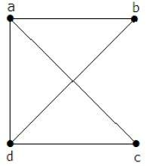
Solution:
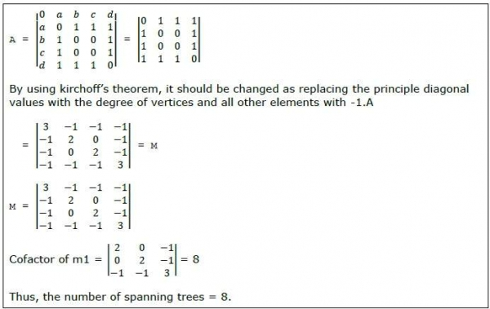

Question # 4: [15 points]: Look into the following argument and answer the following questions.
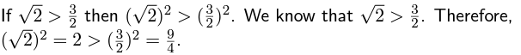
- Is the argument valid, if yes, according to which inferencing rule?
- Does the conclusion must be true, if not Why? Specify the condition.
- What is wrong?
Answer:
- The argument is valid: modus ponens inference rule.
- We cannot conclude that the conclusion is true, since one of its premises, √ 2 > 3/2 , is false.
- Indeed, in this case the conclusion is false, since 2 ≯ 9/4 = 2.25.

Question 5. Using handshaking theorem and draw the graph with following specification if possible? Variants may exist? (18 Points)
- Graph with four vertices with the degree of (One, Two, Two, Three, Three).
- Graph with four vertices with the degree of 90 (One, Two, Two, Three, Three).
- Simple graph with four vertices of degree (One Two Three Four).
- Complete graph with four vertices of degree same degree to all vertices.
- Complete graph with four vertices of degree different degree to all vertices.
- Regular graph with four vertices of degree (One Two Three Four).
1 | 2 | 3 | 4 | 5 | 6
NA | NA | Applicable | Applicable | NA | NA

Note: Students must provide the variant of graph if applicable.
Question 6. Let R be the relation originated from the set {1, 2, 3} (5 Points)
A x A = { (1, 1) , (1, 2) , (1, 3) , (2, 1) , (2, 2) , (2, 3) , (3, 1) , (3, 2) , (3, 3) }
Where R is:
R = { (1, 1) , (1, 3) , (2, 2) , (2, 3) , (3, 1) }
Find R’ complementary relation of it.
R’={ (1, 2), (2, 1), (3, 2), (3, 3) }

Question 7. The following Matrix are the representation of two relation set P R (7 Marks)
$\left[\begin{aligned}101 \\ 110 \\ 000\end{aligned}\right]$*$\left[\begin{aligned}010 \\ 001 \\ 101\end{aligned}\right]$
Find the composite relation of it.

Solution is: $\left[\begin{aligned}111 \\ 011 \\ 000\end{aligned}\right]$

